O.mykiss Siletz 2023 genotyping summary

**QC**

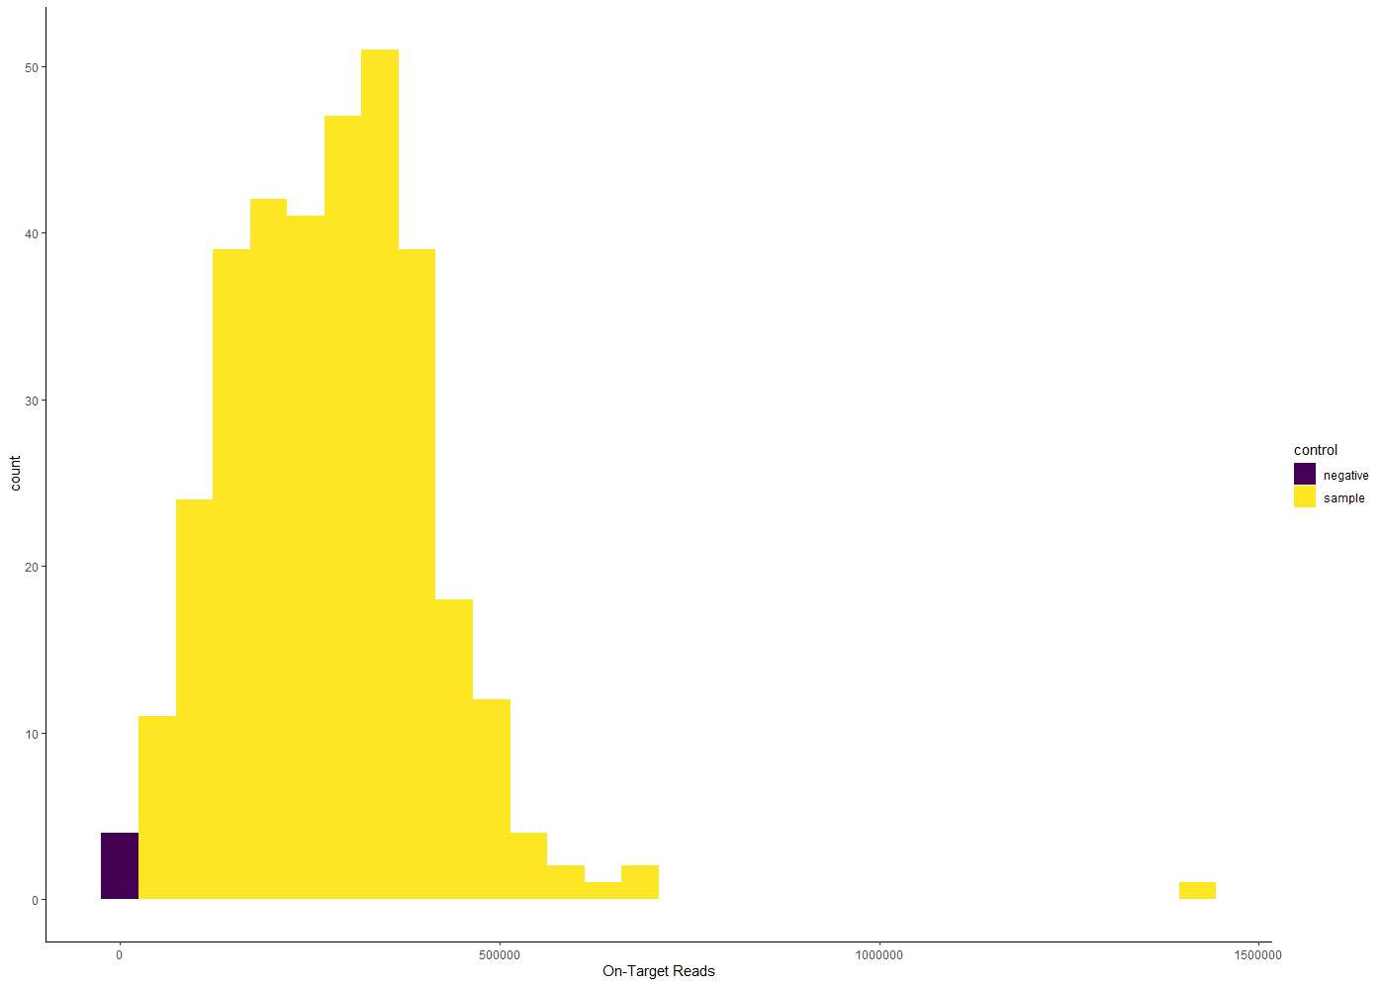

4 negative controls. They have very few “On-Target” reads which is good.

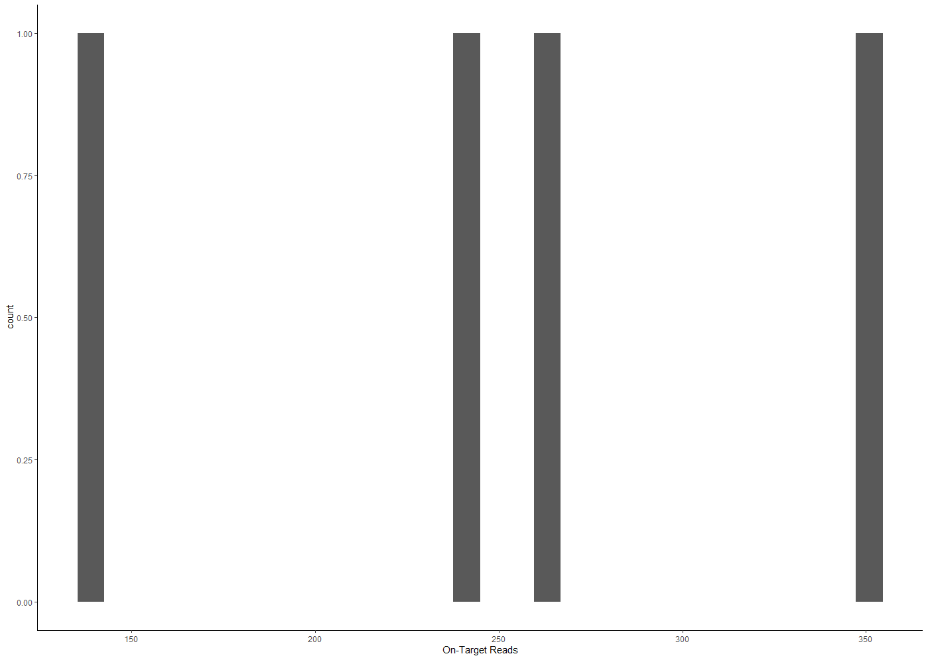

On-Target reads range 139-351 in 4 negative controls.

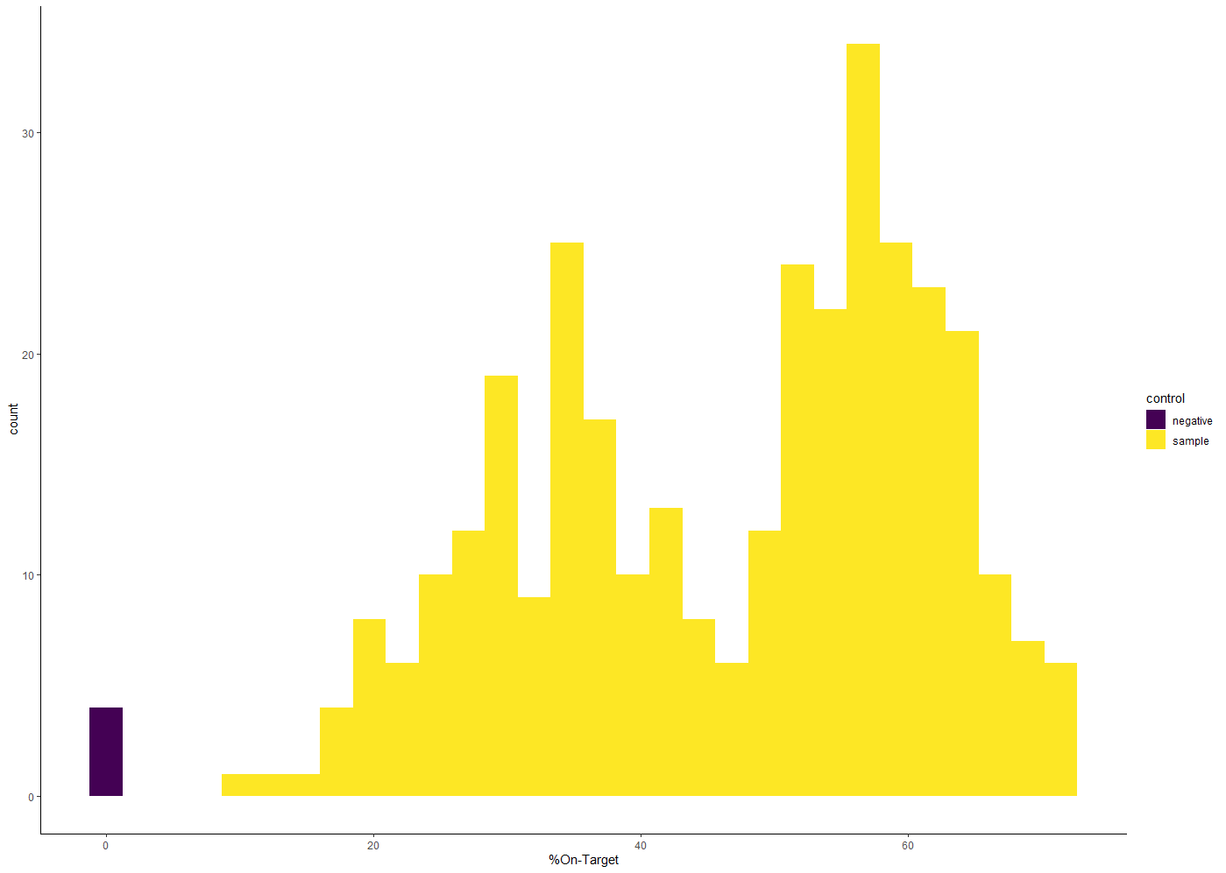

% On-Target ranges 0.03-0.16% for 4 negative controls.

% On-Target ranges 10.46-71.48% for samples.

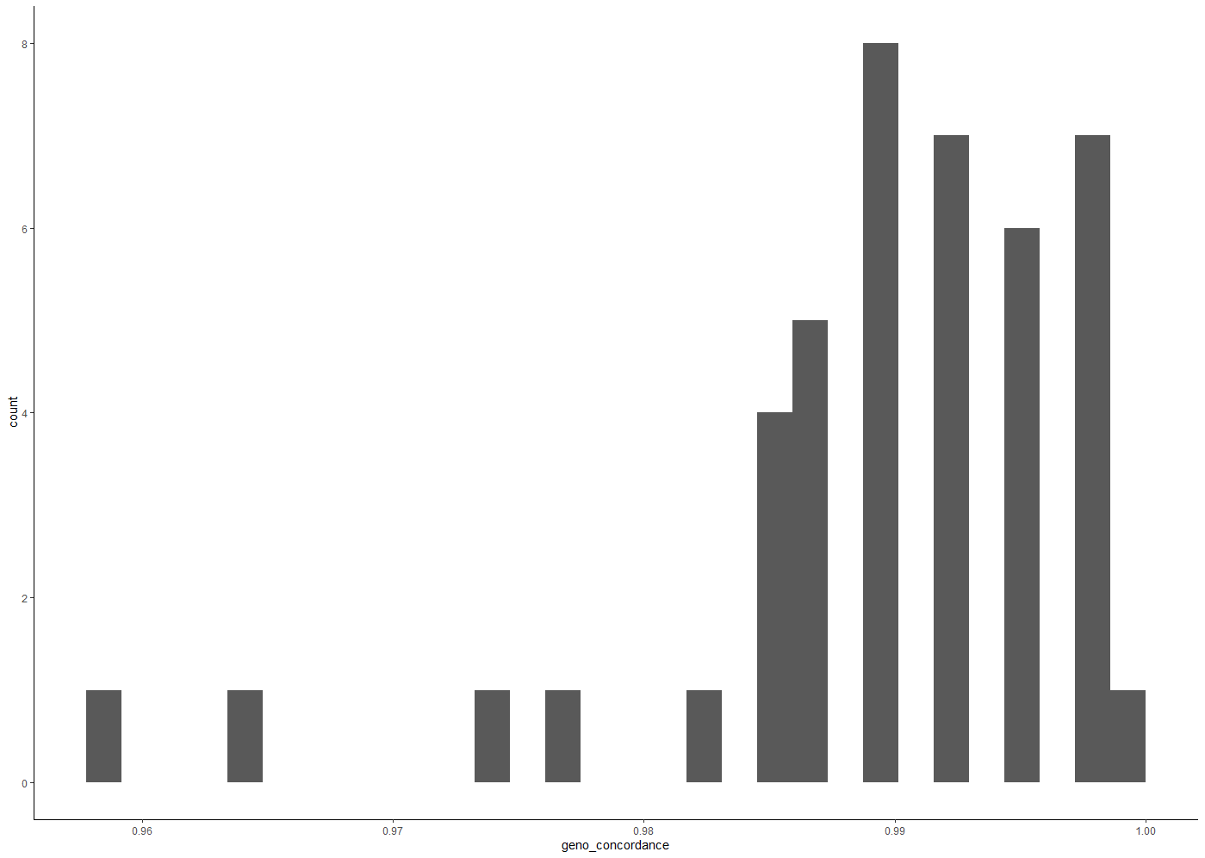

86 repeated samples. High concordance among them 0.95-1.00

291 unique sample_simple names. Genotyped at 390 loci and a sex marker.

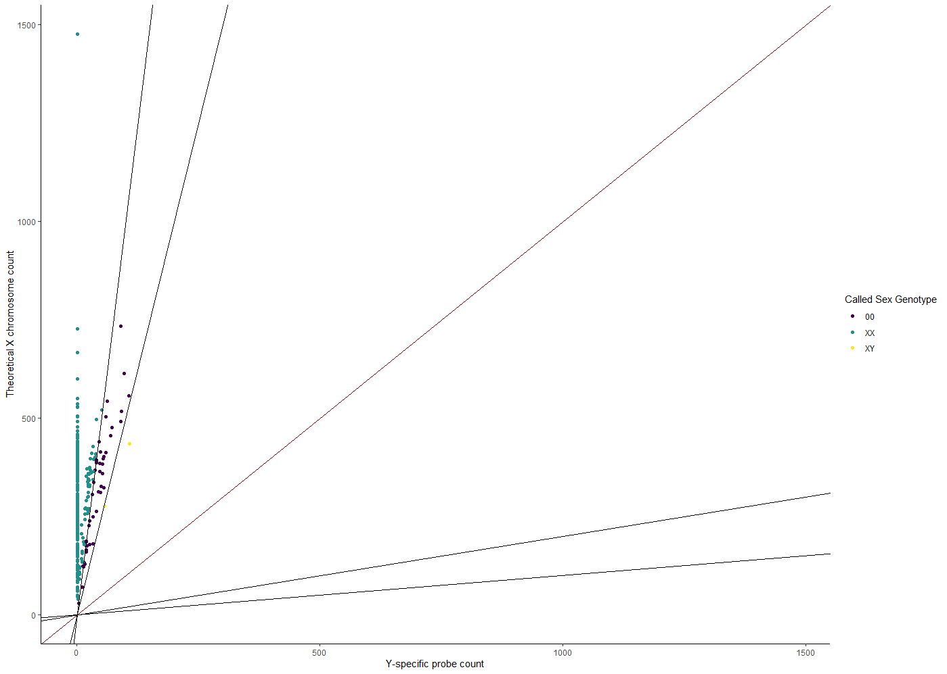

Sex genotyping needs correction. (Before correction)

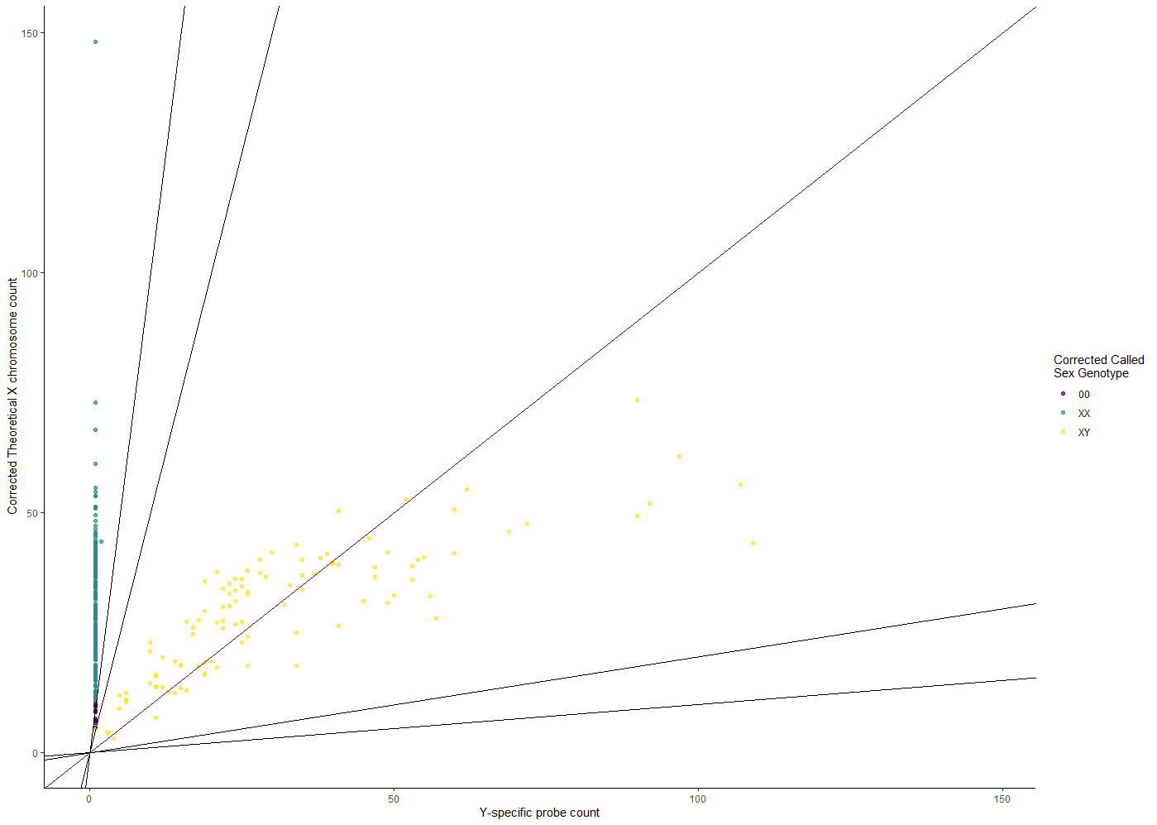

Correction appears to work. (After correction).

95 males, 187 females, 9 undetermined in 291 unique samples.

**Filtering**

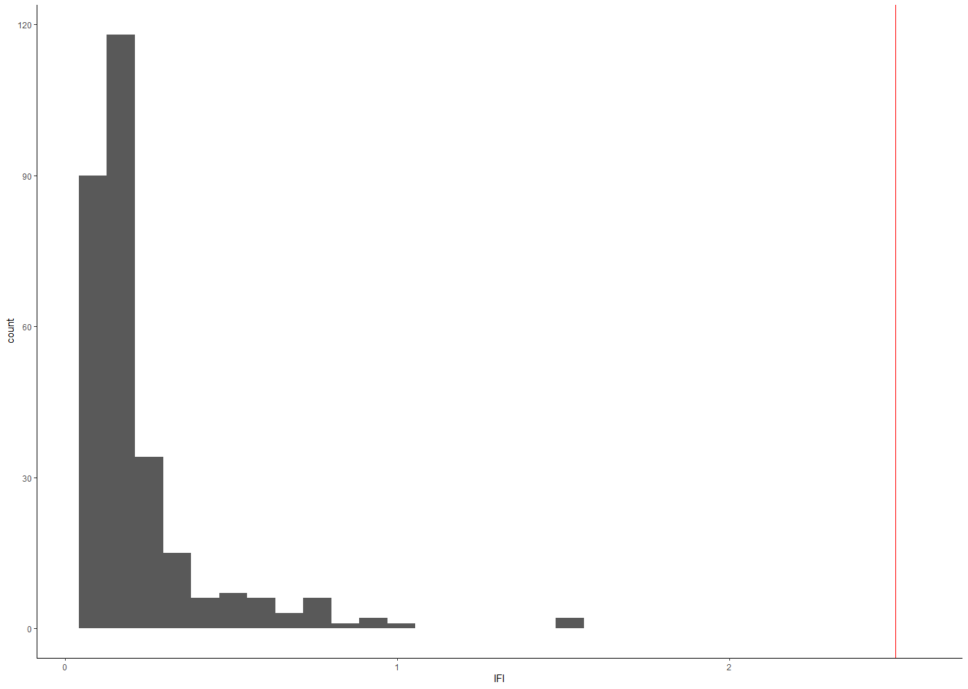

Low IFI scores for 291 samples which is good.

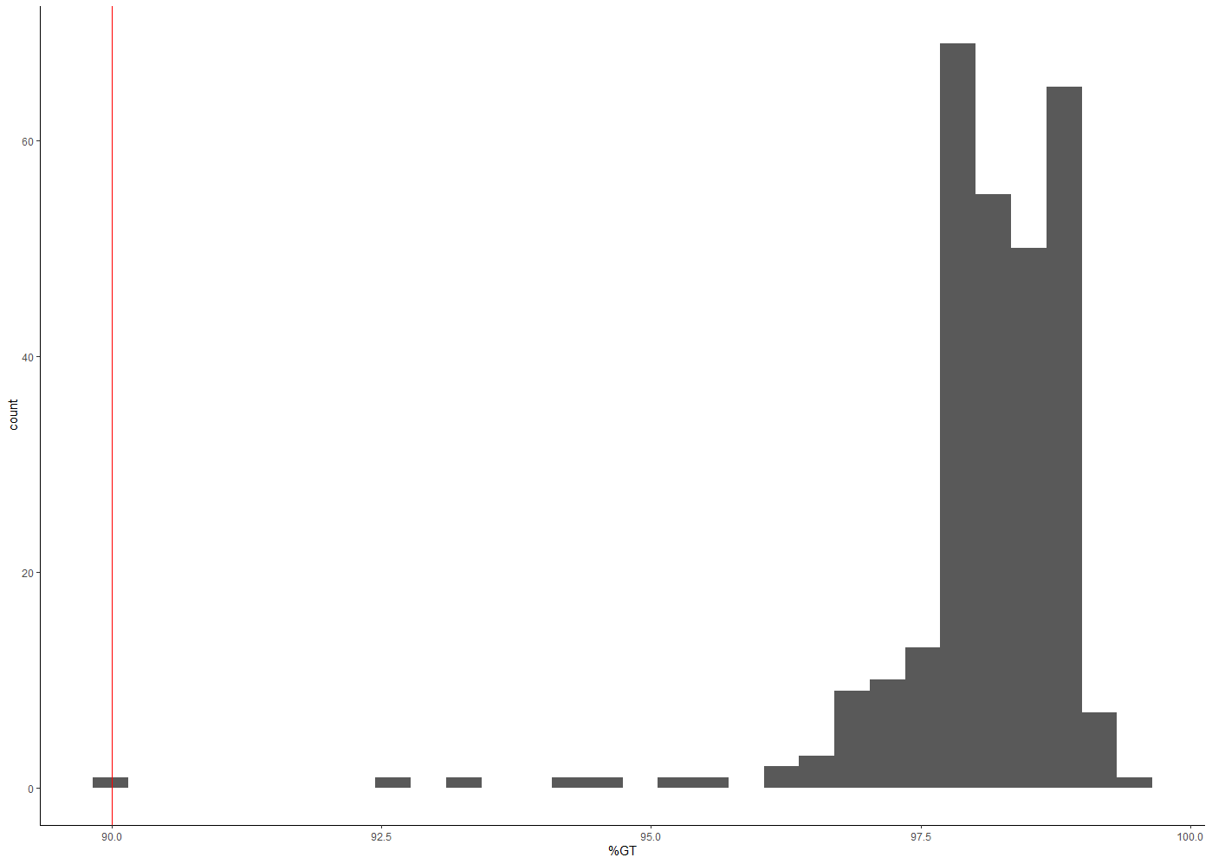

Percentage of loci genotyped in each sample range 90-99% which is good.

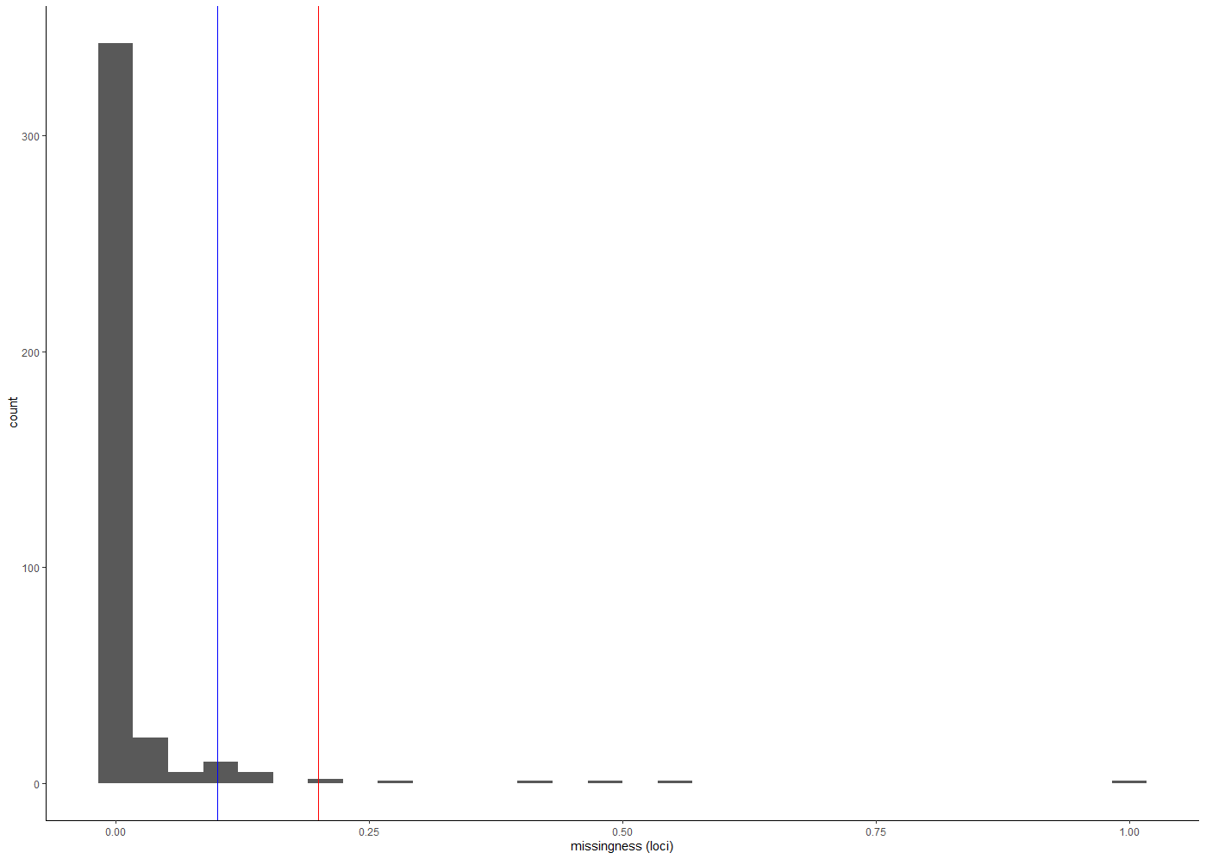  
Most loci amplified in the great majority of samples. One locus (Omy_RAD40520-48) didn’t amplify in any sample….

Removed two loci that amplified in less than half of samples (Omy_RAD40520-48 & Omy_RAD2277-7).

After removing these 2 loci, recalculated IFI. Range 0.05 – 1.6. Still well below final cutoff of 2.5. Good.

Removed three loci that amplified in less than 80% of samples (Omy_104569-114, Omy_RAD14541-72, Omy_RAD43117-55)

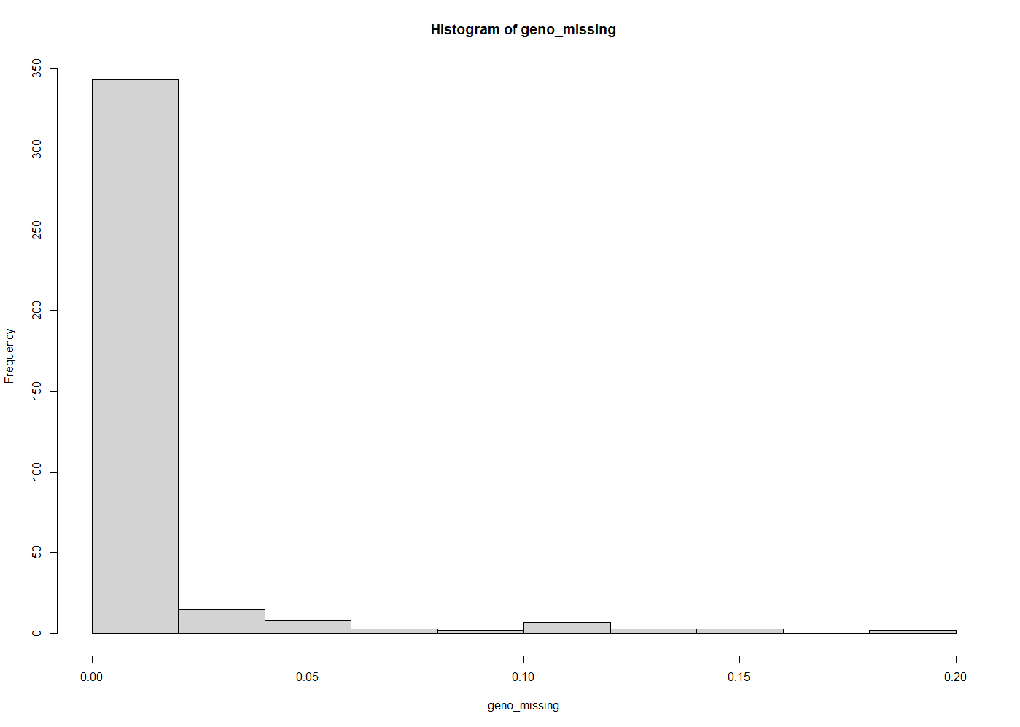

Dataset now has 291 individuals genotyped at 385 loci and a sex marker. All markers are genotyped in > 80% of individuals.

Call rates of individuals ranges 91-100%.

15 markers with ‘moderately poor’ genotyping rates (10 – 20% missing call rate):

OmyR40319Pearse, Omy_118205-116, Omy_CRBF1-1, Omy_Ogo4-212,

Omy_RAD13073-16, Omy_RAD27740-55. Omy_RAD2976-26, Omy_RAD30230-25, Omy_RAD30243-74, Omy_RAD69583-33, Omy_RAD74691-49, Omy_RAD92485-64, Omy_cd59b-112, Omy_gsdf-291, Omy_hus1-52

Evaluate ‘allelic balance’ in these 15 markers in heterozygote individuals. Why is heterozygote allelic balance only evaluated in loci with 10-20% missing call rates?

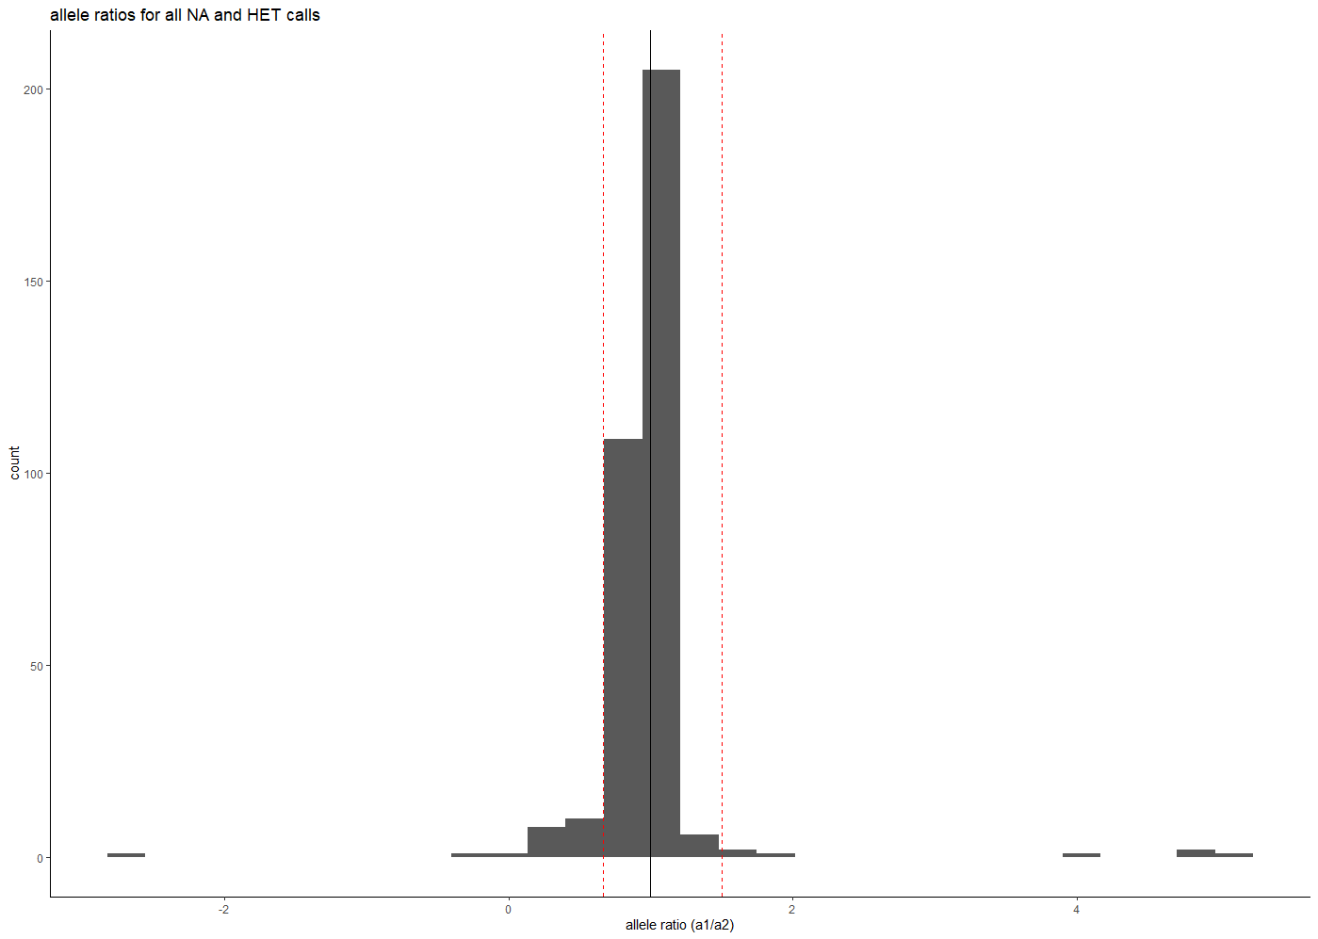

Removed:

Omy_CRBF1-1

Omy_RAD13073-16

Omy_RAD69583-33

Omy_RAD74691-49

Omy_cd59b-112

Omy_hus1-52

Could not evaluate in, so Removed:

OmyR40319Pearse (monomorphic for “A1”)

Omy_RAD27740-55 (low MAF in allele “A2”, very few A2 homozygotes or heterozygotes)

Omy_RAD2976-26 (monomorphic for “A1”)

Omy_RAD30243-74 (monomorphic for “A1”)

Kept:

Omy_118205-116

Omy_Ogo4-212

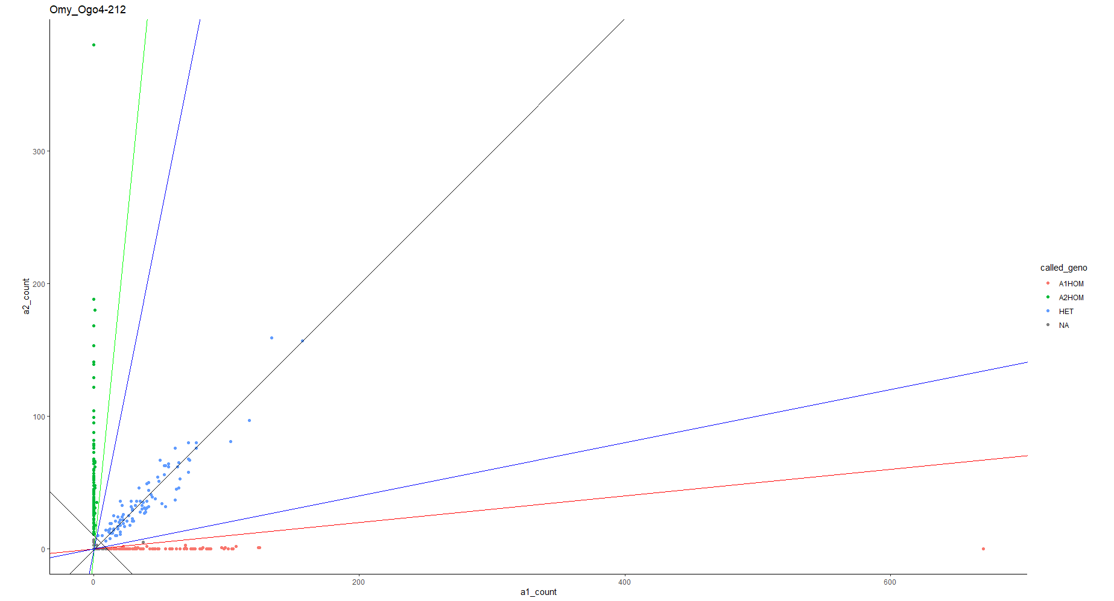

Omy_RAD30230-25

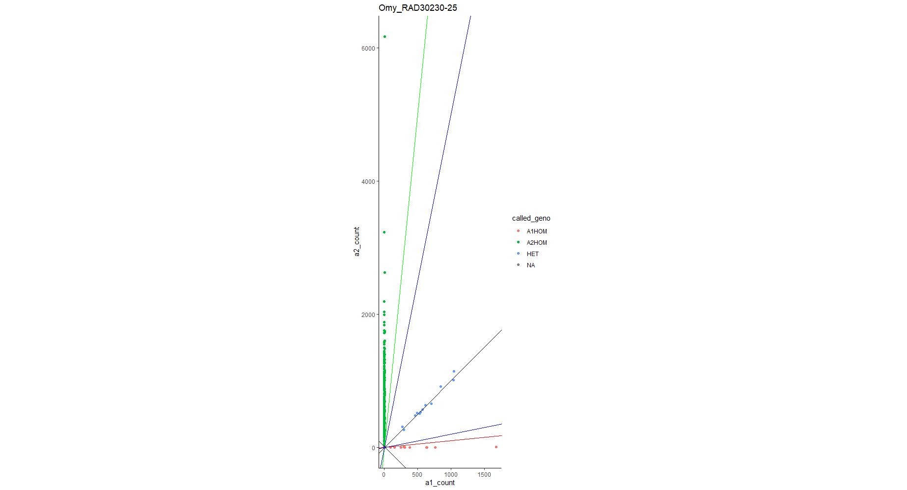

Omy_RAD92485-64

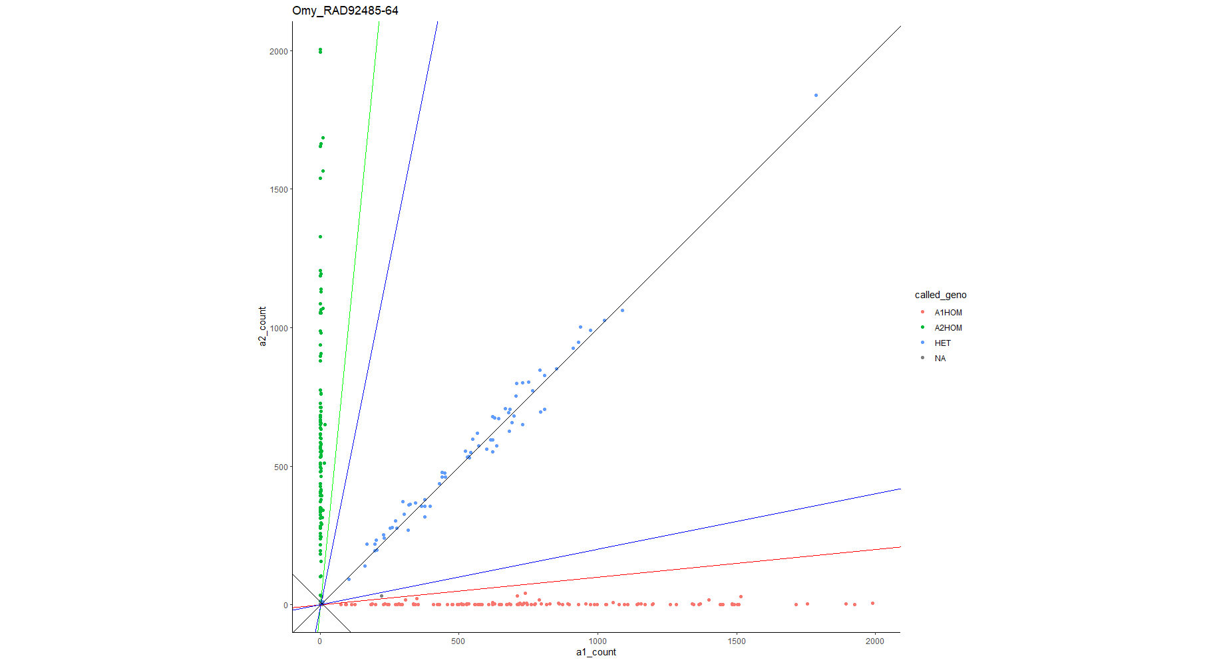

Omy_gsdf-291

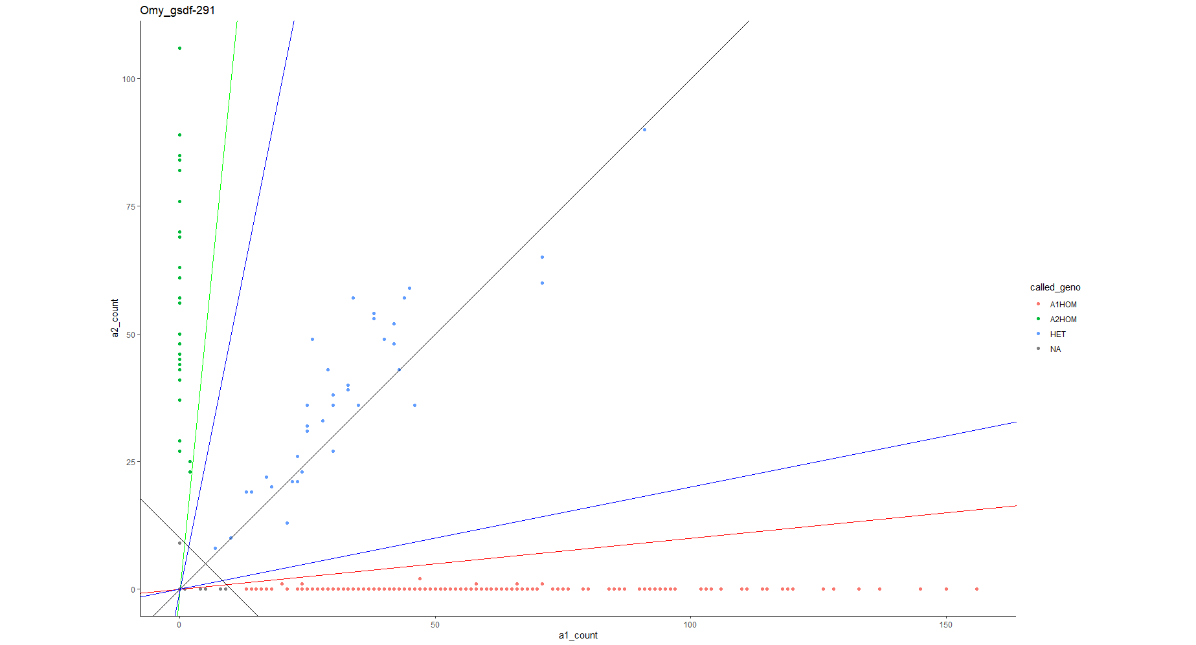

Dataset now has 291 individuals genotyped at 375 loci and a sex marker.

Removed remaining monomorphic markers.

Dataset now has 291 individuals genotyped at 350 loci and a sex marker.

Range in genetic distance among samples 59-219. Thus, no duplicates.

**Summary Stats**

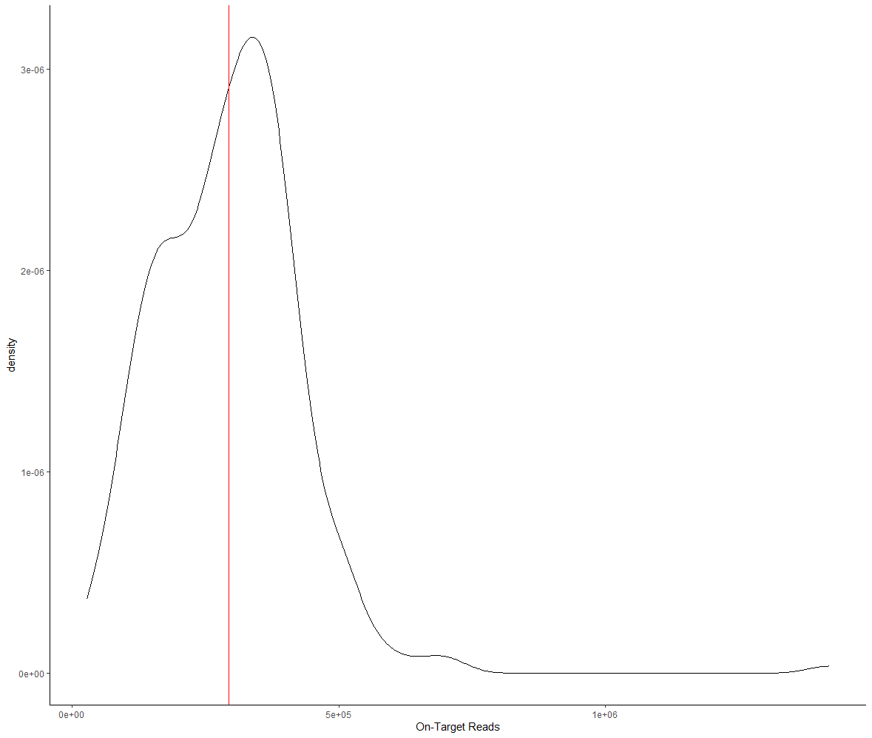

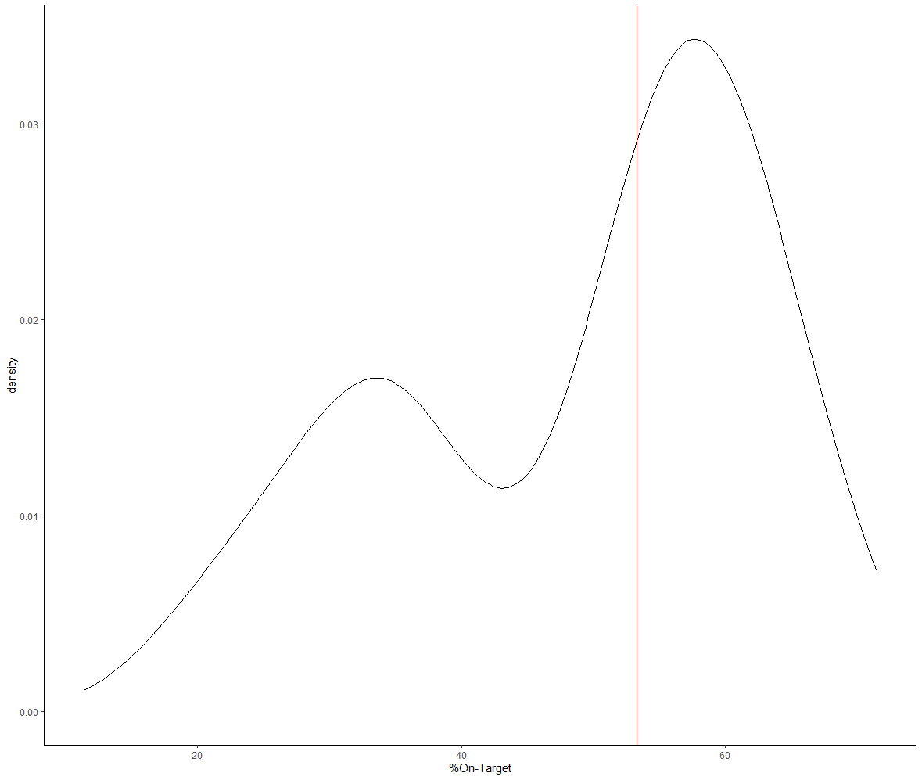

Looks good.

Sequencing depth:

Mean = 752; median = 443; sd = 1048

Good coverage, although quite variable.

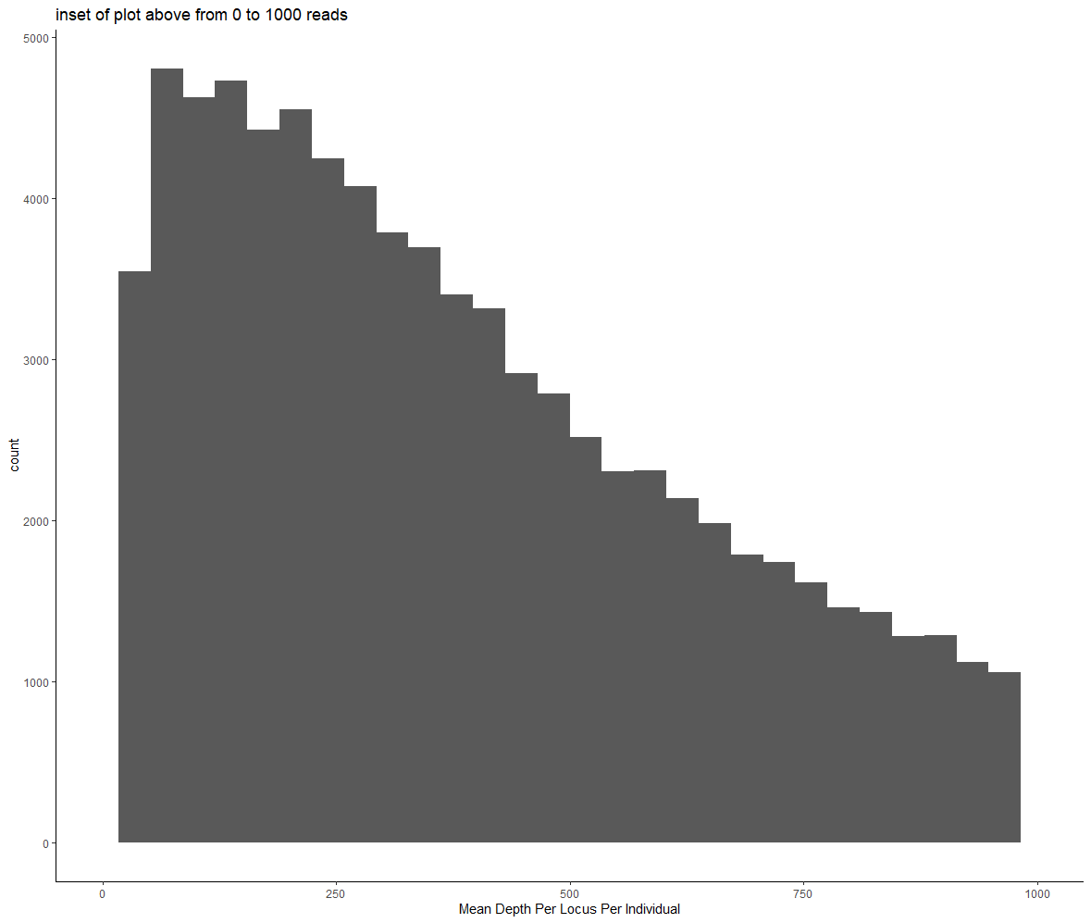

Looks good.